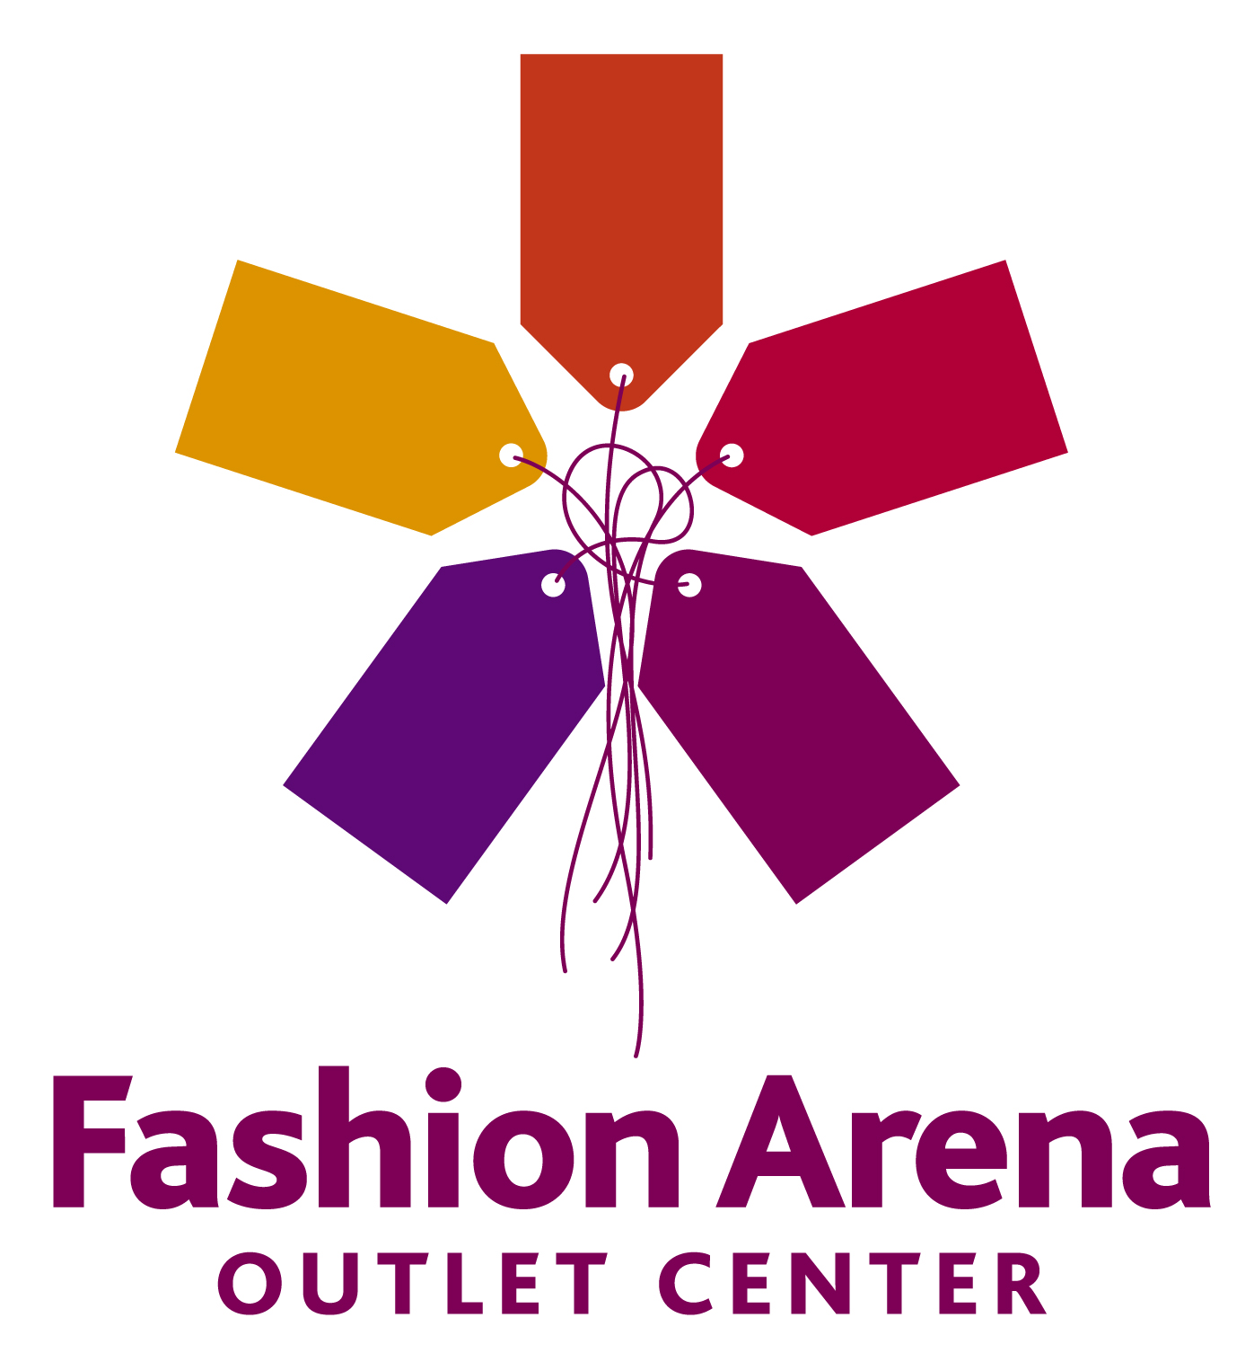

PRESS RELEASE 14 October 2010

eVEN MORE STORES IN fashion arena outlet center

PHASE 2 COMPLETED ON SCHEDULE TO OPEN JUST TODAY

Today at 11 a.m., a ribbon cutting ceremony was held to celebrate the opening of Phase 2 of Fashion Arena Outlet Center. Another 37 new shop units, spread over an area of approx. 7,200 square meters, have been added to the existing 79 stores in Phase 1 whereof 71 shop units are located on the ground floor and 8 units on the first floor (food court units) which in total makes 116 units. Fashion Arena Outlet Center opened in November 2007. Ever since Prague residents and visitors have been attracted by everyday discounts of 30% to 70% off on a wide variety of branded goods: fashion, footwear, leather accessories, sportswear and equipment, underwear, home appliances, toys, luggage, accessories and so on. Fashion Arena Outlet Center is owned by Euro Mall Štěrboholy, and it has been developed by TK Development and LMS Outlets. GEMO Olomouc has been the general contractor for both phases. The total cost has reached CZK 1.6 billion.

A total of 4.5 million shoppers so far have attended Fashion Arena in Štěrboholy, with many of them coming on a regular basis for almost three years since the outlet center opened. The venue has also become popular with customers from the wider surroundings, particularly from the Central Bohemia Region.

“We would like to focus on a wider catchment area next year so that shoppers from the areas that are further away can take advantage of the center. At the same time, we would like to attract more tourists who can combine a visit to the capital city with shopping at our center,” said Thomas H. Villadsen, General Manager, TK Development.

Phase 2 will see the opening of even more stores selling prestigious branded goods –Tommy Hilfiger, Tom Tailor, Tom Tailor Denim, Lindt, Le Creuset, Delsey, Cartoon Land (Disney), LISCA, Bepon, M2 Shoes, Speers, Revolution, Sergio Tacchini, Gear 1963, WITTCHEN, Ecco and Sir Benni Miles. „Some brands will move from Phase 1 to Phase 2 and their shops will be replaced by new and exciting brands. For instance LACOSTE and Kosmas Books with Vossen too relocating. In the Food Court Fruitisimo Ice Cream Factory has opened. Phase 2 will also see opening in October and November of Wildcat Jeans, ChocoSky&Wines, Pery Shoes&Bags and Attrattivo,” stated Graham Coxhead, Deputy Director, Euro Mall Štěrboholy.

It was initially envisaged that Phase 2 would offer 27 new stores that would complete the circuit but, based on tenant demand, their number was increased by another 10 smaller shops. They have a semi-oval-shaped layout mirroring the existing small stores opposite. With Phase 2, the design of Fashion Arena is shown to its best advantage – its oval/horseshoe shape now offer shoppers comfort and convenience.

According to the latest surveys (07/2010), customers visit Fashion Arena Outlet Center, especially because they can find a great number of popular brands sold at attractive discounts there (82%), and the overwhelming majority arrive deliberately and regularly – 90% of visitors come at least once in a half year and 60% visit the center at least once in a quarter year, which is quite an achievement given the fact that the center has no hypermarket, food store or entertainment. Also, customers are ready to cover a relatively longer distance owing to the offer of the center, compared with ordinary shopping centers – almost 45% of visitors travel to the center over 30 minutes although it is favourably located along the South Ring Road.

For further information please contact:

Janu Bakešová, tel. 222 927 111, 731 613 604, jana.bakesova@crestcom.cz

Kamilu Čadková, tel, 222 927 111, 731 613 609, kamila.cadkova@crestcom.cz

